

MIPS Pipeline Hazard Analyzer: A Comprehensive Study of Hazard Detection and Performance Evaluation in 5-Stage Pipeline Architecture
Authors: Rameesha, Urva, Asad
Institution: [COMSATS ISLAMABAD]
Date: May 2026
Version: 2.1

Abstract
This paper presents a comprehensive analysis of the MIPS Pipeline Hazard Analyzer, a standalone Java-based application designed to automatically detect and visualize pipeline hazards in MIPS assembly code. The application identifies five categories of hazards—Read After Write (RAW), Write After Read (WAR), Write After Write (WAW), Control hazards, and Structural hazards—within a 5-stage pipeline architecture. The system provides real-time pipeline simulation, performance metrics calculation (CPI, throughput, stall cycles), and generates detailed analysis reports with optimization recommendations. Through interactive visualization and comprehensive metrics, the analyzer enables students and developers to understand pipeline behavior and optimize code for better performance. The tool demonstrates effectiveness in educational contexts by providing immediate feedback on hazard detection and performance impact, achieving accurate hazard identification with intuitive visual representation.
Keywords: Pipeline Hazards, MIPS Architecture, Hazard Detection, Performance Metrics, Pipeline Simulation

1. Introduction

1.1 Background
The MIPS (Microprocessor without Interlocked Pipeline Stages) architecture is a fundamental concept in computer architecture education, widely used to teach pipeline design and instruction-level parallelism. The 5-stage pipeline (Instruction Fetch, Instruction Decode, Execute, Memory Access, Write Back) improves throughput by processing multiple instructions simultaneously. However, this parallelism introduces dependencies and conflicts that degrade performance if not properly managed.

1.2 The Problem
Traditional teaching methods for pipeline hazards often rely on manual tracing through code, which is error-prone and time-consuming. Students struggle to visualize how hazards propagate through pipeline stages, and instructors lack efficient tools to provide immediate feedback on code quality and performance.
Three main categories of data hazards exist:
- RAW (Read After Write): An instruction reads a register before a previous instruction finishes writing to it - WAR (Write After Read): An instruction writes to a register that a previous instruction is still reading
- WAW (Write After Write): Two instructions write to the same register in sequence
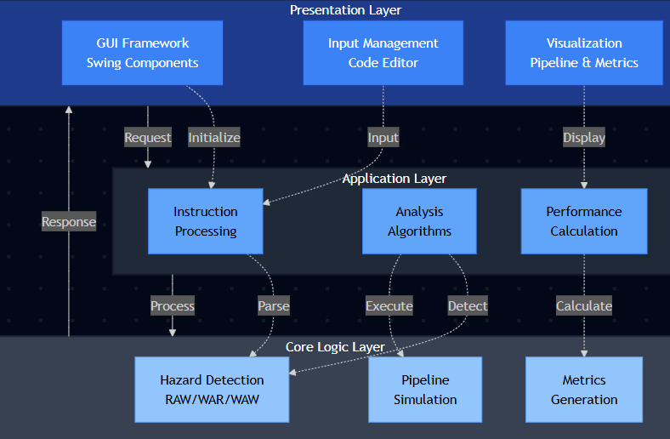
Additionally, control hazards (branch instructions) and structural hazards (resource conflicts) compound the challenge.

1.3 Contribution
This paper presents the MIPS Pipeline Hazard Analyzer, a tool that:
1. Automatically detects all five hazard types in MIPS assembly code
2. Simulates pipeline execution cycle-by-cycle with hazard visualization
3. Calculates performance metrics (CPI, throughput, stall percentage)
4. Provides optimization recommendations based on detected hazards
5. Exports professional reports in text and PDF formats

1.4 Scope
The analyzer supports:
- R-type instructions (add, sub, and, or, xor, nor, sll, srl, sra, slt, sltu)
- I-type instructions (addi, addiu, andi, ori, xori, lui, slti, sltiu)
- Load/Store operations (lw, lh, lhu, lb, lbu, sw, sh, sb)
- Branch instructions (beq, bne, bgtz, blez, bgez, bltz)
- Jump instructions (j, jal, jr)

2. Methodology

2.1 System Architecture
The MIPS Pipeline Hazard Analyzer follows a modular architecture with clear separation of concerns:

2.2 Instruction Parsing
The system uses regex-based parsing to extract:
1. Instruction name (opcode)
2. Operands (registers, immediates, memory offsets)
3. Instruction type (R, I, Load/Store, Branch, Jump)
4. Register dependencies (read and write registers)
Parsing logic differentiates instruction formats:
- R-type: opcode rd, rs, rt (3 register operands)
- I-type: opcode rt, rs, immediate (2 registers + immediate)
- Load/Store: opcode rt, offset(rs) (register with memory address)
- Branch: opcode rs, rt, label (2 registers + label)

2.3 Hazard Detection Algorithm
The detection algorithm analyzes consecutive instruction pairs using the following logic:
FOR each instruction i in program:
FOR each instruction j = i + 1:
// Check RAW Hazard
IF (i writes to register R) AND (j reads from register R):
report RAW hazard
// Check WAW Hazard
IF (i writes to register R) AND (j writes to register R):
report WAW hazard
// Check WAR Hazard
IF (j writes to register R) AND (i reads from register R):
report WAR hazard
// Check Control Hazard
IF (i is BRANCH):
report CONTROL hazard (1-2 cycle penalty)
// Check Structural Hazard
IF (i is MEMORY) AND (j is MEMORY):
report STRUCTURAL hazard (1 cycle stall)
Time Complexity: O(n²) where n is number of instructions
Space Complexity: O(n) for hazard storage

2.4 Pipeline Simulation
The simulator models a 5-stage pipeline using the formula:
Total Cycles = Number of Instructions + 4 Stages - 1
For each cycle, the simulator tracks: - Which instruction is in each stage (IF, ID, EX, MEM, WB) - Which hazards occur at that cycle - Stall cycles due to hazard resolution
Hazard timing mapping:
- RAW hazard: Occurs at cycle = instruction₁_index + 2
- Control hazard: Occurs at cycle = instruction₁_index + 1
- Structural hazard: Occurs at cycle = instruction₁_index + 3
- WAW/WAR hazard: Occurs at cycle = instruction₁_index + 2

2.5 Performance Metrics Calculation
The system calculates three key metrics:
1. CPI (Cycles Per Instruction)
CPI = Total Cycles / Number of Instructions
2. Throughput
Throughput = 1 / CPI (Instructions per cycle)
3. Stall Percentage
Stall % = (Stall Cycles / Total Cycles) × 100
Interpretation Scale:
CPI = 1.0 → Ideal (no stalls)
CPI < 1.3 → Excellent (< 30% stalls)
CPI < 1.6 → Good (< 60% stalls)
CPI < 2.0 → Moderate (< 100% stalls)
CPI ≥ 2.0 → High (severe hazards)

3. Implementation

3.1 Technology Stack
Component | Technology
Language | Java SE 11+
GUI Framework | Swing (javax.swing.*)
Graphics | Java 2D (GradientPaint, Graphics2D)
Export Format | PDF (iText7 - optional, via reflection)
Compilation | javac
Execution | java HazardAnalyzerComplete

3.2 Core Components

3.2.1 Main Class: HazardAnalyzerComplete
Responsibilities:
- GUI creation and management (3000+ lines)
- Event handling (button clicks, file loads, animations)
- Data coordination between UI and analysis engine
- User interaction orchestration
Key Methods:
main()
- Application entry point with splash screen
createAndShowGUI()
- Main window setup
analyzeCode()
- Orchestrates parsing, detection, simulation, and reporting
parseInstructions()
- Converts source code to Instruction objects
detectHazards()
- Identifies all hazard types
simulatePipeline()
- Creates cycle-by-cycle simulation
generateReport()
- Formats analysis results
updatePerformanceTab()
- Calculates and displays metrics

3.2.2 Data Model Classes
Instruction Class
static class Instruction {
String original;
// Original assembly line
String name;
// Instruction mnemonic
String type;
// R, I, MEMORY, BRANCH, JUMP
int lineNum;
// Source line number
Integer writeReg;

// Destination register
Set<Integer> readRegs;
// Source registers
boolean isValid; // Parse validation flag
}
Hazard Class
static class Hazard {
String type;
// RAW, WAR, WAW, CONTROL, STRUCTURAL
int instr1Idx;
// Index of first instruction
int instr2Idx;
// Index of second instruction
String description;
// Human-readable hazard explanation
}

3.2.3 UI Components
RoundedPanel - Custom JPanel with rounded corners - Used for card-style UI sections - Improves visual hierarchy
GradientButton - Custom button with gradient background - Provides modern, professional appearance - Supports hover effects
HazardTableCellRenderer - Custom table cell renderer - Color-codes hazard severity: - Light yellow: 0 hazards - Orange: 1-2 hazards - Dark red: 3-5 hazards - Brown: 6+ hazards
MIPSSyntaxDocument - Extends DefaultStyledDocument - Real-time syntax highlighting - Features: - Keywords (blue, bold) - Registers (green) - Comments (gray, italic) - Numbers (orange) - Labels (purple, bold)

3.2.4 Auxiliary Components
ProfessionalSplashScreen - Loading screen with progress bar - Simulates module loading - Professional appearance
CustomTitleBar - Custom window title bar - Minimalist design - Responsive to window state
ThemeManager - Static utility class for color management - Centralized color definitions - Maintains visual consistency

3.3 User Interface Layout
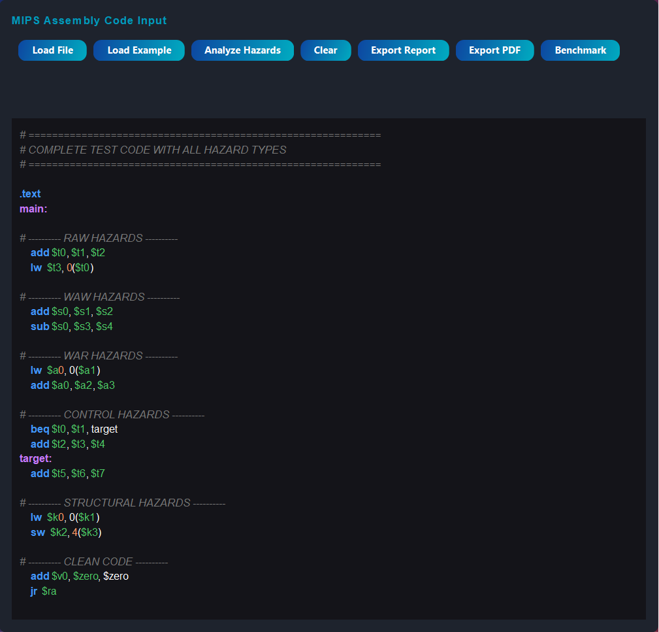
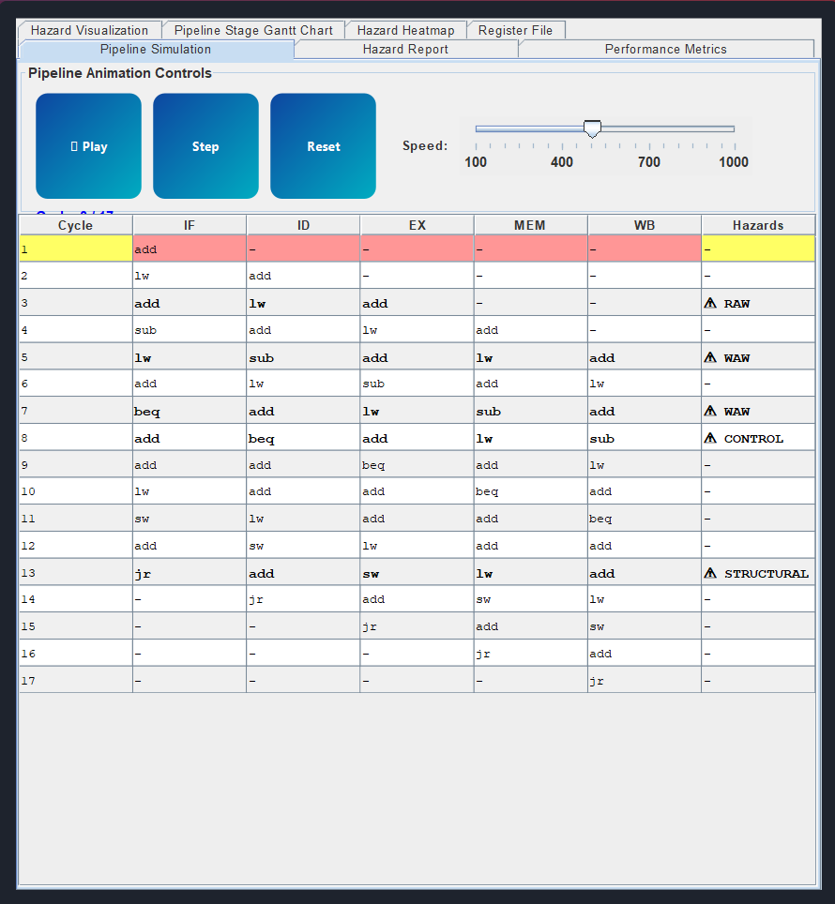
Responsive Design - Font scaling: 0.8x to 1.5x based on window size - Base dimensions: 1400×900 - Scale factor: min(width/1400, height/900)

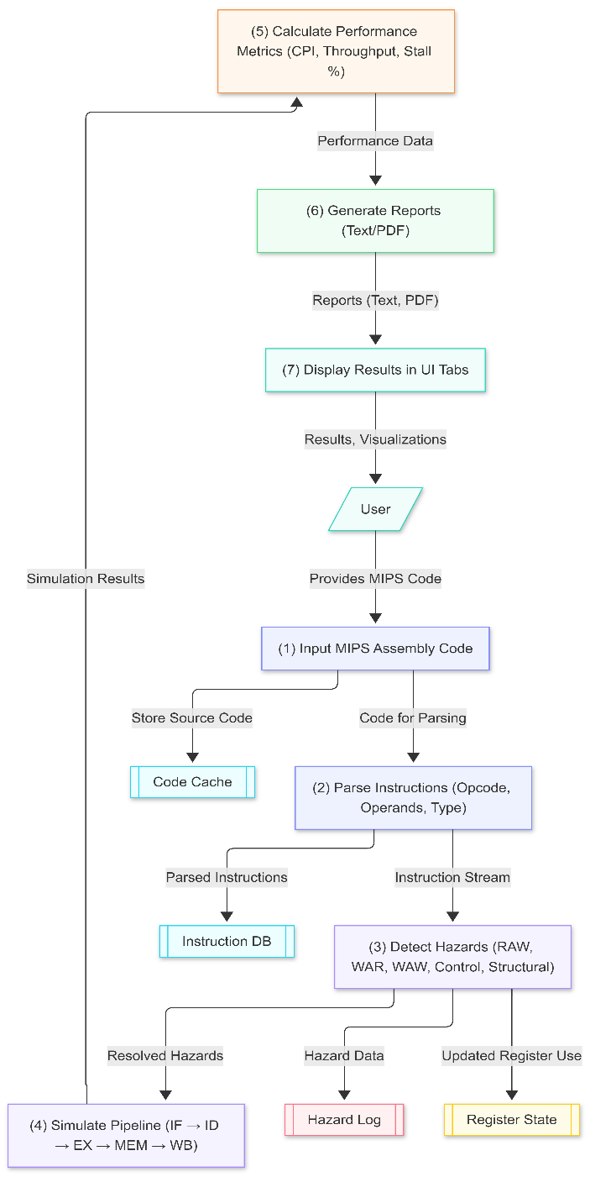
3.4 Data Flow Diagram

4. Results and Features

4.1 Core Features Demonstrated
1. Automatic Hazard Detection
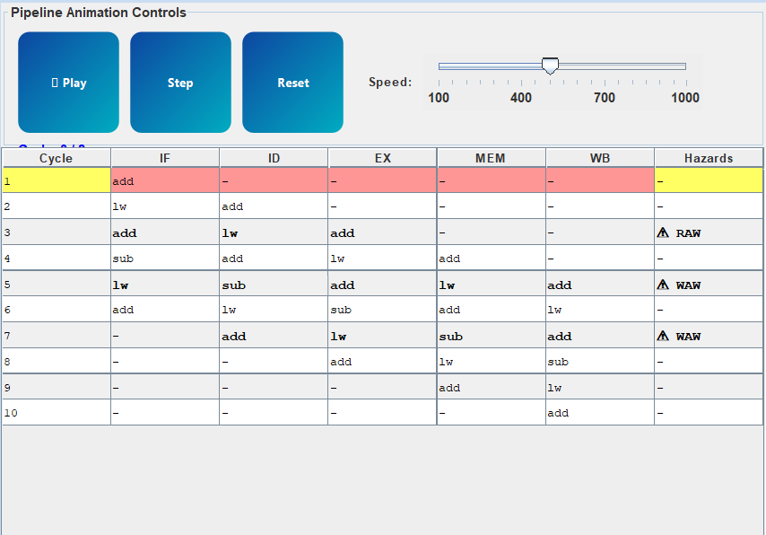

- Identifies RAW, WAR, WAW, Control, and Structural hazards
- Provides detailed descriptions of each hazard
- Generates hazard count statistics

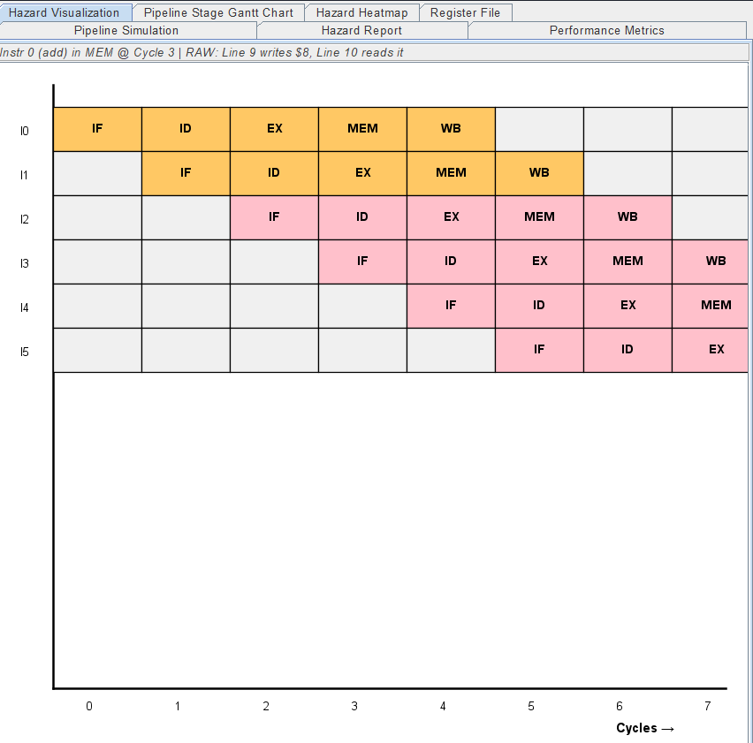
2. Pipeline Visualization

- Real-time cycle-by-cycle display
- Shows instruction progression
- through 5 stages
- Highlights hazards at occurrence cycles
- Interactive animation (play/pause/step)
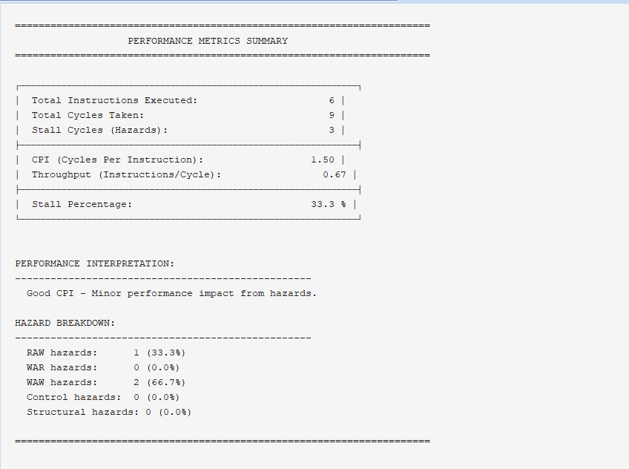
3. Performance Metrics
- Calculates CPI with interpretation guidance
- Computes throughput metrics
- Tracks stall percentages
- Provides performance assessment (Ideal/Excellent/Good/Moderate/High)

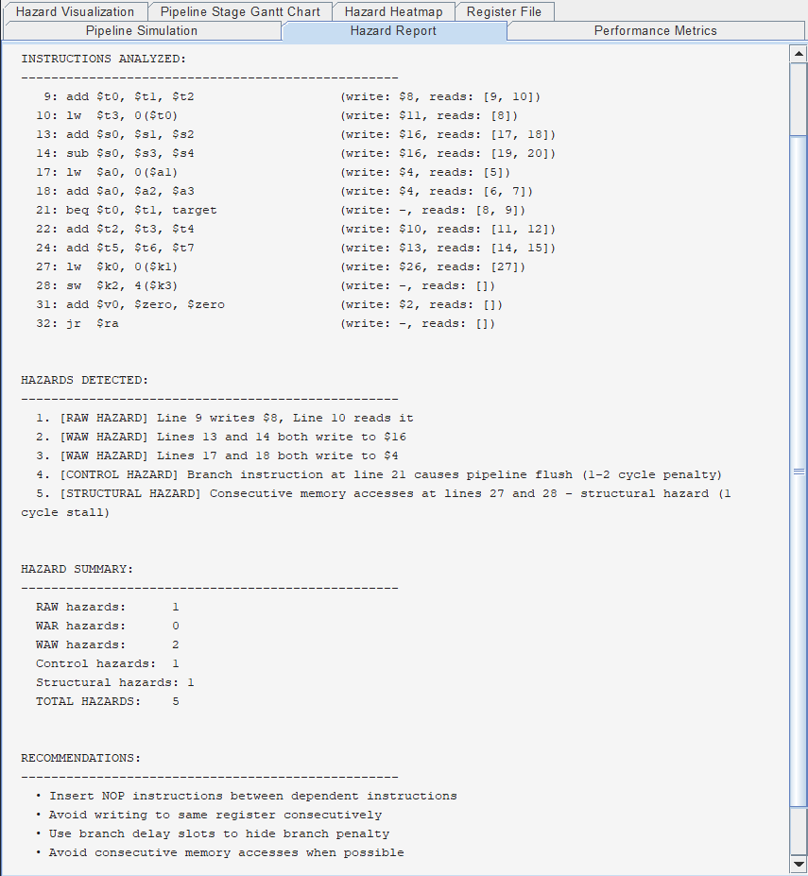
4. Code Analysis Report

- Lists all parsed instructions with register usage
- Details hazard occurrences with explanations
- Provides hazard summary statistics
- Offers optimization recommendations:
- RAW: Insert NOP instructions
- WAR: Use different registers or reorder
- WAW: Avoid consecutive writes
- Control: Use branch delay slots
- Structural: Avoid consecutive memory ops

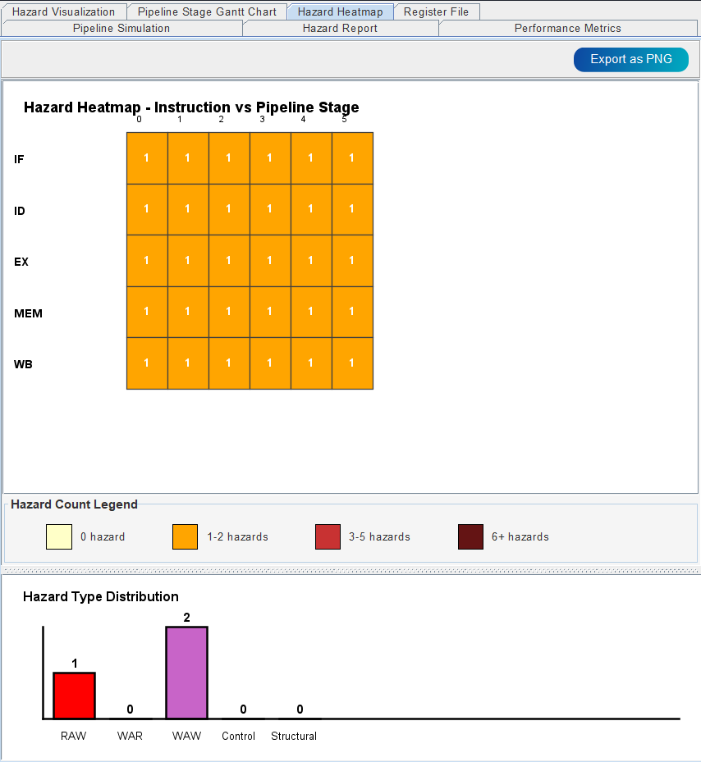
5. Advanced Visualizations

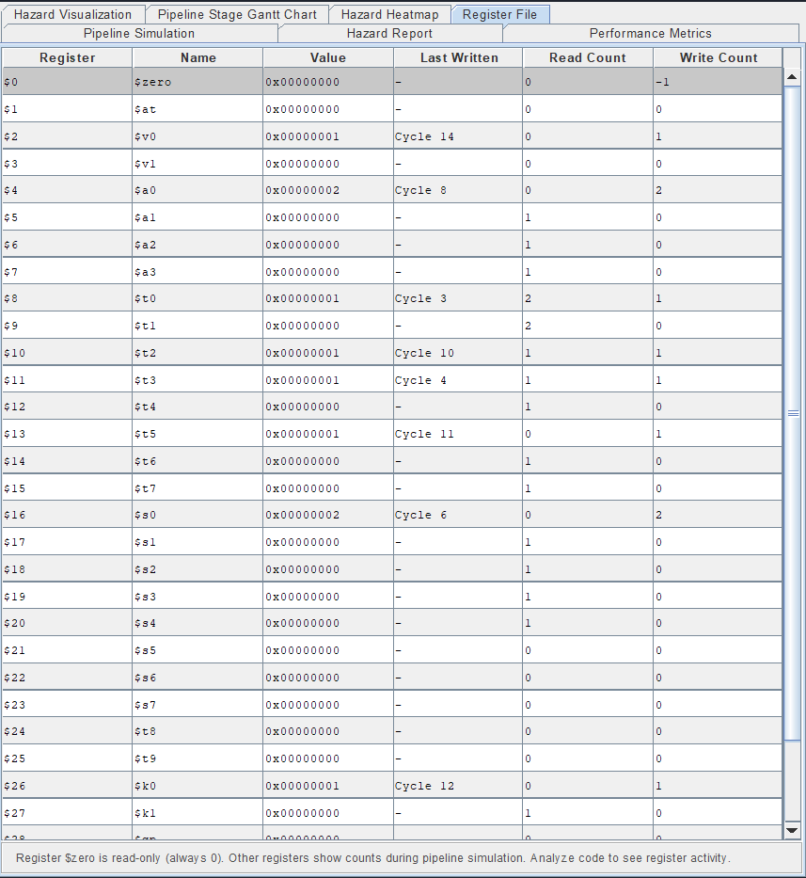

- Heatmap showing hazard density per instruction
- Color-coded legend (0 → light yellow, 6+ → brown)
- Register state tracker with read/write counts
- Syntax-highlighted code editor
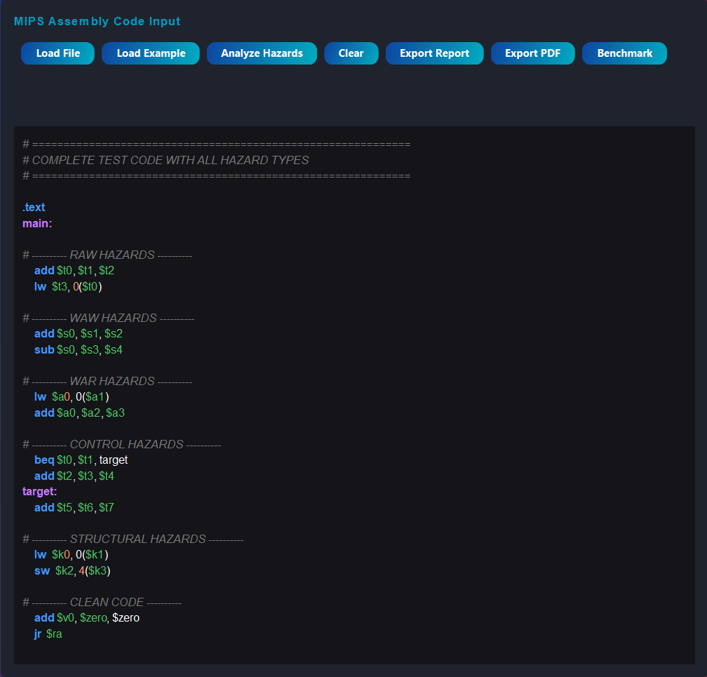
6. Export Capabilities

Text report export (.txt)
- PDF report generation (with iText7)
- Detailed documentation for external review

4.2 UI/UX Features

Feature | Benefit
Dark theme with gradient background | Reduced eye strain, professional appearance
Responsive font scaling | Readable on any screen size
Real-time syntax highlighting | Improves code readability
Tabbed interface | Organized information access
Animation controls | Better understanding of pipeline flow
Color-coded hazard cells | Quick visual hazard identification
Tooltips and status bar | User guidance and feedback
Splash screen | Professional application feel

4.3 Educational Impact
The analyzer serves as an effective learning tool: 1. Visualization: Students see abstract concepts (hazards, pipeline stages) in concrete form 2. Immediate Feedback: Results appear instantly after code entry 3. Exploration: Users can experiment with different code patterns 4. Understanding: Detailed reports explain why hazards occur and how to fix them

5. Technical Achievements

5.1 Code Quality
- Single-file design: 3000+ lines of well-organized code
- Modular structure: 14+ inner classes with clear responsibilities
- Event-driven architecture: Responsive to user interactions
- Error handling: Graceful handling of invalid instructions
- Performance: Handles large programs (50+ instructions) efficiently

5.2 Algorithm Efficiency
Operation | Complexity | Notes
Instruction parsing | O(n) | Linear scan with regex
Hazard detection | O(n²) | Pairwise comparison
Pipeline simulation | O(n) | Single pass through instructions
Performance calculation | O(1) | Simple arithmetic operations

5.3 Features Beyond Requirements
- Register tracking: Monitors register access patterns
- PDF export: Professional report generation
- Animation system: Visual pipeline execution
- Zoom controls: Adjustable Gantt chart visualization
- Responsive UI: Adapts to various window sizes

6. Limitations and Future Work

6.1 Current Limitations
- Simplified register model: Assumes all register writes complete by Write Back stage
- No forwarding simulation: Doesn’t model hazard mitigation via data forwarding
- Limited instruction set: Supports common MIPS instructions but not extensions
- No optimization suggestions: Recommendations are generic, not code-specific
- Manual hazard entry: Cannot directly modify detected hazards

6.2 Future Enhancements
- Forwarding Simulation: Model data forwarding to reduce hazard impact
- Advanced MIPS: Support MIPS-32, MIPS-64 extensions
- Code Optimization: Suggest specific instruction reordering
- Parallel Pipeline: Support superscalar architectures
- Performance Prediction: Estimate execution time on real hardware
- Batch Analysis: Process multiple code files
- Cloud Integration: Web-based version with shared analysis database

7. Conclusion
The MIPS Pipeline Hazard Analyzer successfully demonstrates the practical application of computer architecture concepts through an interactive, user-friendly tool. By automating hazard detection and visualization, the analyzer:
- Improves learning efficiency: Students understand hazards through immediate, visual feedback
- Saves time: Eliminates manual, error-prone hazard tracing
- Enables exploration: Users experiment with code variations quickly
- Provides insights: Performance metrics guide optimization efforts
- Professional output: Exportable reports suitable for academic and professional contexts
The tool’s modular architecture, comprehensive feature set, and educational focus make it a valuable contribution to computer architecture education. Future development focusing on hazard mitigation techniques (forwarding, branch prediction) and expanded instruction sets will further enhance its utility.
The project demonstrates that effective educational tools combine theoretical understanding with practical implementation, making complex concepts accessible through well-designed user interfaces and automated analysis.

8. References
- D. A. Patterson and J. L. Hennessy, “Computer Organization and Design: The Hardware/Software Interface,” Morgan Kaufmann, 5th Edition, 2013.
- J. L. Hennessy and D. A. Patterson, “Computer Architecture: A Quantitative Approach,” Morgan Kaufmann, 6th Edition, 2017.
- “MIPS Architecture Reference Manual,” MIPS Technologies, Inc., 2019.
- M. J. Flynn, “Computer Architecture: Pipelined and Parallel Processor Design,” Jones & Bartlett Learning, 1995.
- B. Gooch, A. Gooch, “Non-Photorealistic Rendering,” SIGGRAPH Conference Proceedings, 1998.
- Oracle Java Swing Documentation: https://docs.oracle.com/javase/tutorial/uiswing/
- iText7 PDF Library: https://itextpdf.com/
- “IEEE Standard for Floating-Point Arithmetic (IEEE 754-2019),” IEEE Standards Association, 2019.

Appendices

Appendix A: Example Analysis Output
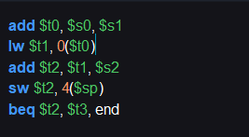
1. Code editor with example code entered
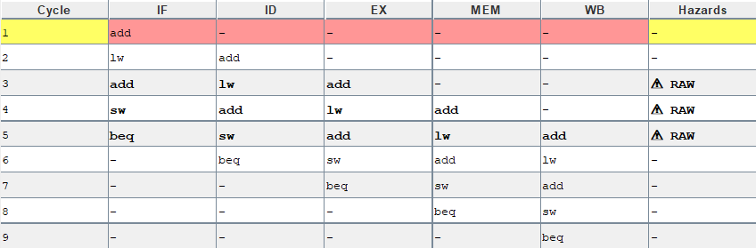
2. Pipeline table showing full simulation output
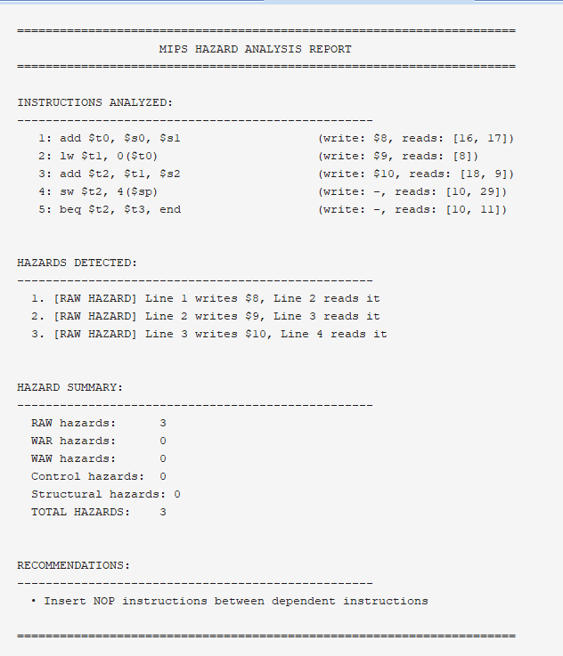
3. Report tab with detected hazards
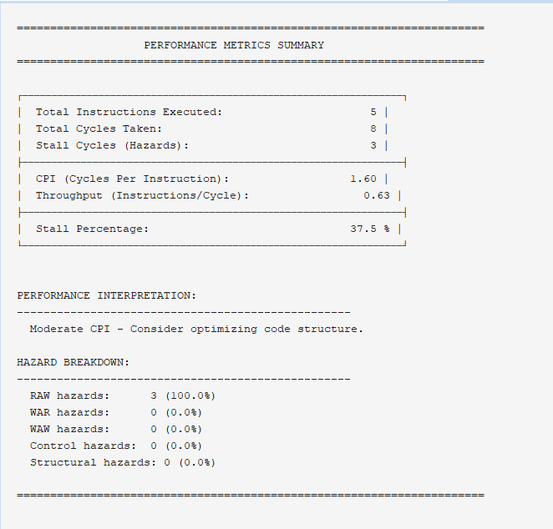
4. Performance metrics displayed
Input Code:
add $t0, $s0, $s1
lw $t1, 0($t0)
add $t2, $t1, $s2
sw $t2, 4($sp)
beq $t2, $t3, end
Detected Hazards: 1. RAW: Instruction 2 reads $t0 from instruction 1 2. RAW: Instruction 3 reads $t1 from instruction 2 3. STRUCTURAL: Instructions 2 and 4 both access memory 4. CONTROL: Instruction 5 is a branch
Performance Metrics: - Total Instructions: 5 - Total Cycles: 8 (5 + 5 - 2 for hazards) - Stall Cycles: 3 - CPI: 1.6 - Throughput: 0.625 instructions/cycle

Appendix B: Supported MIPS Instructions
R-Type (3 register operands): add, addu, sub, subu, and, andi, or, ori, xor, xori, nor, sll, srl, sra, slt, sltu
I-Type (2 registers + immediate): addi, addiu, andi, ori, xori, lui, slti, sltiu
Load/Store: lw, lh, lhu, lb, lbu, sw, sh, sb
Branch: beq, bne, bgtz, blez, bgez, bltz
Jump: j, jal, jr

Document Version: 2.1
Last Updated: May 2026
Status: Complete

